

# Samsung Galaxy TAB S8

## Type of device: Tablet

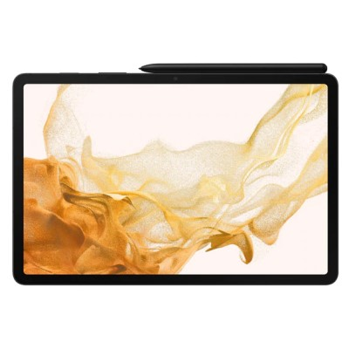

Actual Display Size : 11 inches

Operating System : Google Android

Version(if Android) : Android 12

Network Capability : 3G,4G,5G

Year of Release : 2022

Average Price : $1172 as of 10 06 2022

Internet Access : Wi-Fi and Mobile Broadband

## Accessibility Features:

### Cognitive

* Additional Instructions
* Copy and Paste
* Flicker Free Display
* GPS
* Photo Telephone List
* Screen Timeout Disabled
* Simple Instructions
* Simple Reminders
* Simplify Display

Voice Notes

### Hearing Impairment and Deaf

* Allows for sign language communication
* Bluetooth or Wi-Fi
* Closed Captioning
* Front Facing Camera
* Hearing Aid Microphone Coupling
* Hearing Aid Telecoil Coupling
* Text Messaging/SMS
* Vibrating Alerts - Adjustable
* Video Communications - Two-way

Visual Alerts - Incoming Calls

### Vision

* Accessibility APIs supported
* Battery Alert - Audible
* Bluetooth or Wi-Fi
* Braille Display Support
* Brightness Adjustable
* Dictation / Speech-to-Text
* High Contrast Mode
* Personalised Shortcuts
* Power Cue
* Screen Magnifier
* Screen Reader
* Text Size Adjustable
* Text Style Adjustable
* Voice Control /Personal Assistant

Voiced Menus

### Speech

* Allows for sign language communication
* Bluetooth or Wi-Fi
* Messaging Options - Email
* Messaging Options - IM
* Messaging Options - MMS
* Predictive Text

SMS Personalisation and Reuse

### Physical

* Bluetooth or Wi-Fi
* Dictation / Speech-to-Text
* Gesture Based Navigation
* Predictive Text
* Reduced hand movement option
* Speaker-phone option
* Stylus or Prosthetic Device support
* Switch control option
* Visible Focus Indicators
* Voice Control / Personal Assistant
* Voice Recognition for Accessing Features

Voice Recognition for Dialling

## How and where to get it from?

You can buy this tablet from [Telstra](https://www.telstra.com.au/tablets/tablets-on-a-plan/samsung/galaxy-tab-s8), [Optus](https://www.optus.com.au/business/mobile/tablets/samsung/galaxy-tab-s8), [Vodafone](https://www.vodafone.com.au/tablets/samsung-galaxy-tab-s8-5g?capacity=128GB&color=Dark%20Grey&contractTerm=36), [Samsung](https://www.samsung.com/au/tablets/galaxy-tab-s/galaxy-tab-s8-ultra-wifi-graphite-128gb-sm-x900nzaaxsa/), [JB Hi-Fi](https://www.jbhifi.com.au/search?query=samsung%20s8&page=1), [Dick Smith](https://www.dicksmith.com.au/da/shop/?q=samsung+galaxy+tab+s8), [Office Works](https://www.officeworks.com.au/shop/officeworks/search?istCompanyId=0403b0ba-0671-498f-aeb7-e2ff71b61924&istFeedId=00ff5695-1f12-4ff3-82f4-49dd39a43a69&istItemId=pliwallqa&istBid=t&cm_mmc=Google:SEM:Always_on:RP|Technology|Tablets%20&%20eReaders||Samsung|||SH||Supplier=&s_kwcid=AL!12073!3!544007127760!!!g!1634743279419!s_kwcid=AL!12073!3!544007127760!!!g!1634743279419!&gclid=EAIaIQobChMIv5jbqZed-AIVmJJmAh1m0QosEAQYBCABEgKkefD_BwE&gclsrc=aw.ds&q=samsung%20galaxy%20s8&view=grid&page=1&sortBy=bestmatch), and other retailers.

## More information is available on:

[Samsung Galaxy TAB S8 Website](https://www.samsung.com/au/tablets/galaxy-tab-s8/buy/?cid=au_pd_ppc_google_tablets-tab-s8_lch_im:ao-gdc-paid-cdm_keyword_keyword_search&gclid=EAIaIQobChMIpsLXpJCi-AIVWiQrCh0iuQ9yEAAYASAAEgLz6vD_BwE&gclsrc=aw.ds)

[Samsung Galaxy TAB S8 User Manual PDF Download](https://downloadcenter.samsung.com/content/UM/202202/20220210182808865/SM-X70X_X80X_X90X_UM_EU_SS_Eng_Rev.1.0_220208.pdf)